RGB Color Object Detection Using MATLAB

Basic Step for Detecting Red Color Object from Image:

1. Read The RGB Image
2. **Extract Red Component from the Original Snapshot**
3. **Subtract red-color Components from the grey**
4. **Image (new grey image)**
5. **Remove the noise from the new grey image**
6. **by using filter command.**
7. **Convert the filtered image into binary image**
8. **(get bright image in place of the red object)**
9. **Measure parameters of the bright image and place a rectangular box over it.**

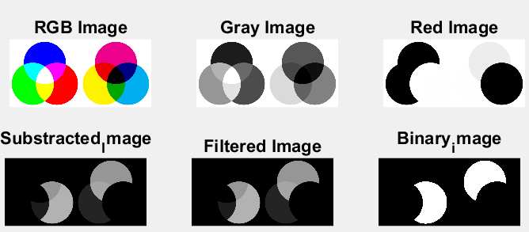

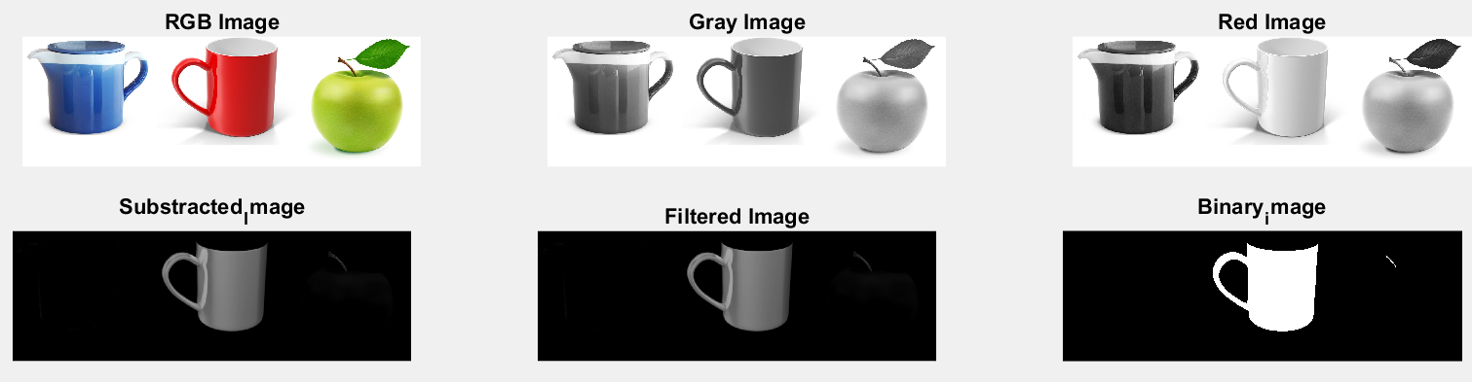

%Reading RGB Image

rgbimage=imread('Rgb_image2.png');

%Converting RGB Image Into Gray

grayimage=rgb2gray(rgbimage);

%Extracting Red Componet from rgbimage

red_image=rgbimage(:,:,1);

% Substracting grayimage from red_image

substract_image=red_image-grayimage;

%Filter out (Remove Noise) from substract_image

filter_image=medfilt2(substract_image,[3,3]);

%Converting flter_image into Binary Image for Morphological operation

binary_image=imbinarize(filter_image,.18);

%ploting all the image

subplot(2,3,1)

imshow(rgbimage)

title("RGB Image")

subplot(2,3,2)

imshow(grayimage)

title("Gray Image")

subplot(2,3,3)

imshow(red_image)

title("Red Image")

subplot(2,3,4)

imshow(substract_image)

title("Substracted_Image")

subplot(2,3,5)

imshow(filter_image)

title("Filtered Image")

subplot(2,3,6)

imshow(binary_image);

title("Binary_image")

image_morph=bwareaopen(binary_image,300);

n,image_bw=bwlabel(image_morph,8);

stats=regionprops(image_bw,'BoundingBox','Centroid');

figure

imshow(rgbimage)

hold on

for obj=1:length(stats)

bbox=stats(obj).BoundingBox;

bcentroid=stats(obj).Centroid;

rectangle('Position',bbox,'EdgeColor','r','LineWidth',2)

plot(bcentroid(1),bcentroid(2),'-m+')

a=text(bcentroid(1)+15,bcentroid(2)+15,strcat('X: ',num2str(round(bcentroid(1))),'Y: ',num2str(round(bcentroid(2)))));

set(a,'FontName','Arial','FontWeight','bold','FontSize',12,'Color','black');

end

hold off

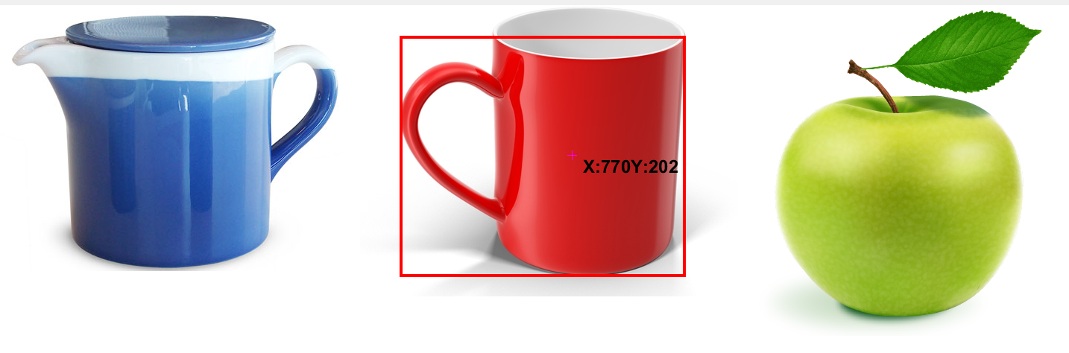

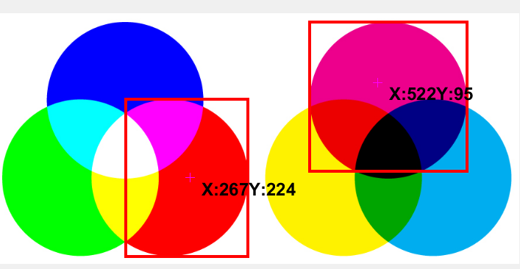

regionprops:

This is used to measure the image properties.

stats regionprops(BW,properties)

stats = regionprops(BW,properties) returns measurements for the set of properties specified by properties for each 8-connected component (object) in the binary image.stats is struct array containing a struct for each object in the image. You can use regionprops on contiguous regions and discontiguous regions.

Calculate centroids for connected components in the image using regionprops.

s = regionprops(BW,'centroid')

bwareaopen:

Remove small objects from binary image

BW2 = bwareaopen(BW,P) removes all connected components (objects) that have fewer than P pixels from the binary image BW, producing another binary image, BW2. The default connectivity is 8 for two dimensions

bwlabel

Label connected components in 2-D binary image

L = bwlabel(BW) returns the label matrix L that contains labels for the 8-connected objects found in BW. The label matrix, L, is the same size

[L,num] = bwlabel(___) also returns num, the number of connected objects found in BW.